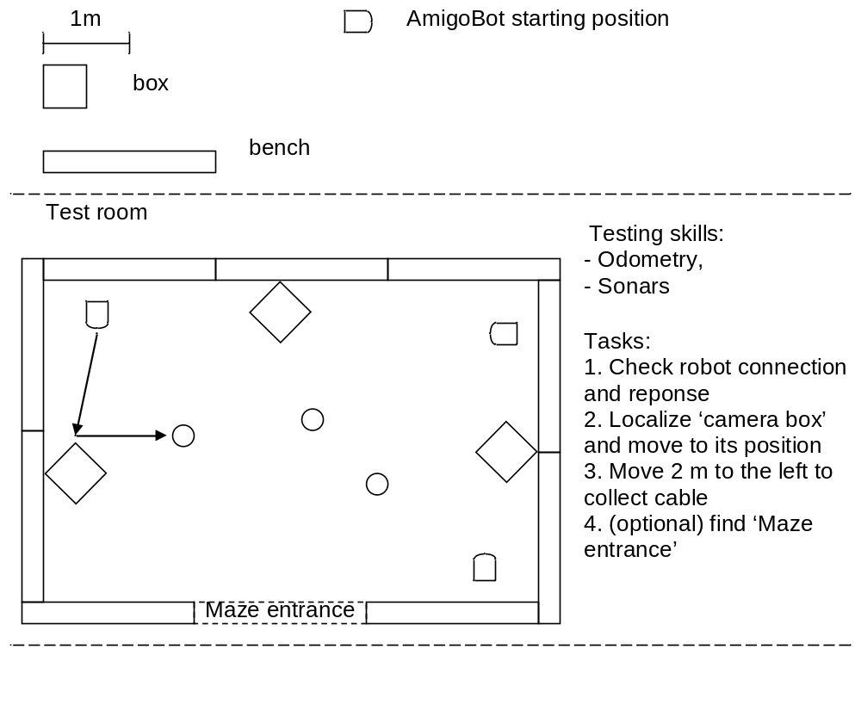
Rules:
1. Movement:
- Cannot hit any object
- Blue box – always keep on right side
- Green box – always keep on left side
- Red box – always stop, move left 0,5m, move ahead 1m
2. Figures:
- Circle – make figure A with robot movement, turn around
- Triangle – make figure B with robot movement, turn around
- Square – make figure C with robot movement, turn around
- Marker – go to marker, exit the Maze
3. Checkpoints:
For every completed checkpoint team receive points. Teams may attempt to complete any checkpoint after completing Test room tasks. Checkpoint tasks:
- 1 use odometry and sonars to chose direction of robot movement,
- 2 use sonars to avoid obstacles,
- 3, 4 use camera to detect color of the box, make decision based on detected color, follow movement rules,
- 5, 6, 7 use camera to detect shape of figure, design figure A/B/C using odometry, make figure A/B/C with robot movement, go back to main chamber
- Maze Exit – use camera to detect AR Pose Marker and exit the Maze
- Room entrance – additional task – large room 6x6m for participants ideas
